
School of Computer Science and Information Systems
Winter Semester 2025-2026
Agile Development Process and Devops Lab

Course faculty- SWETA BHATTACHARYA
Course Code – ISWE406P
Slot- C1+TC1

ASSESSEMENT-4
Name: DHINESH.S
Reg no: 23MIS0396

CI/CD Pipeline Implementation using Jenkins, Docker, and Kubernetes
Objective
The objective of this assignment is to create and deploy a simple HTML application using a CI/CD pipeline with GitHub, Jenkins, Docker, and Kubernetes.

Tools Used
- GitHub
- Jenkins
- Docker Desktop
- Kubernetes (enabled in Docker Desktop)

Step 1: Project Setup
A GitHub repository was created containing the following files:
1. index.html
A simple webpage was created to display deployment status.
2. Dockerfile
Used to build a Docker image using Nginx.
3. deployment.yaml
Used to deploy the application in Kubernetes.
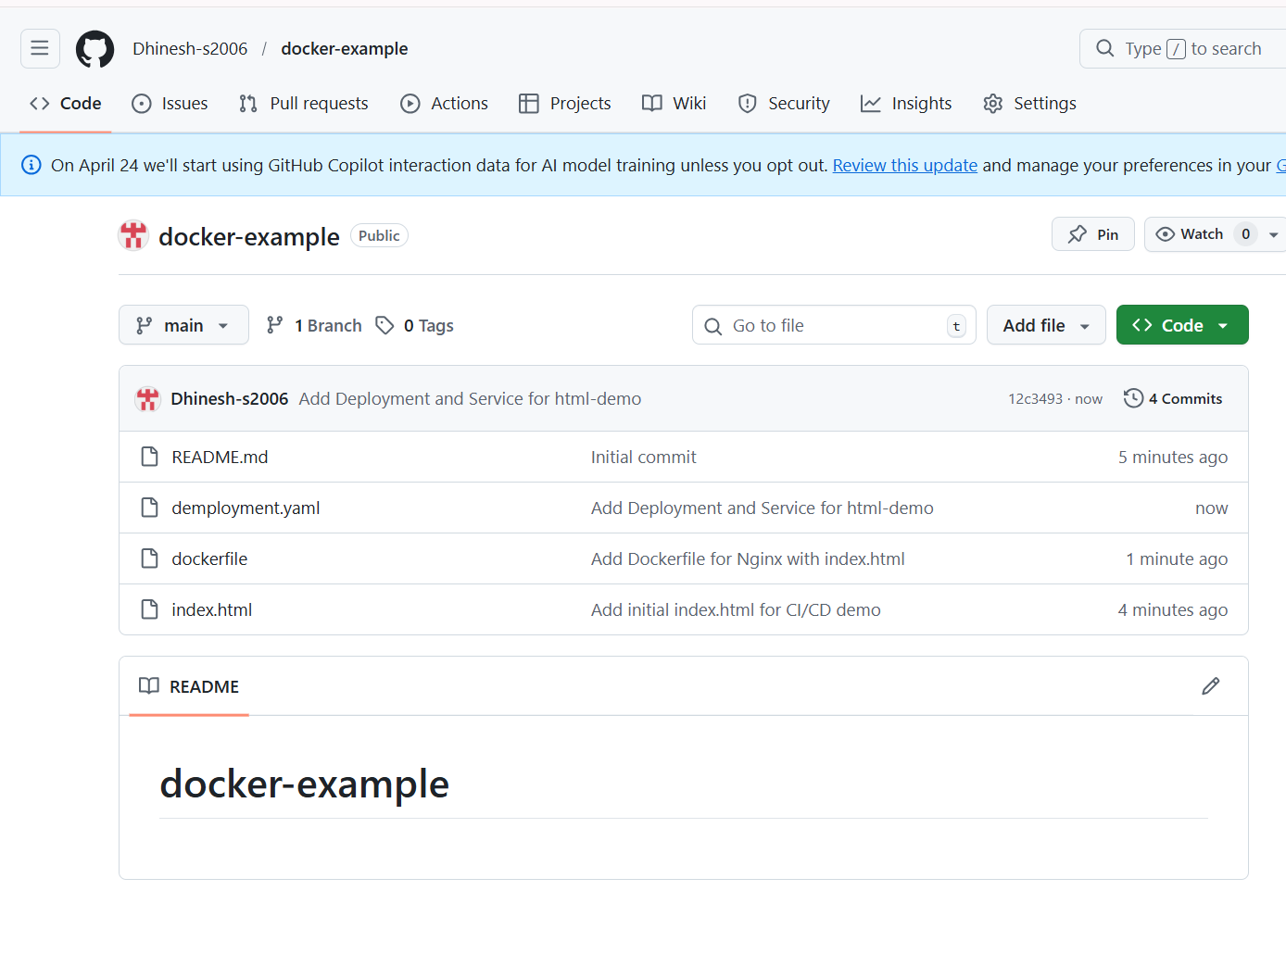
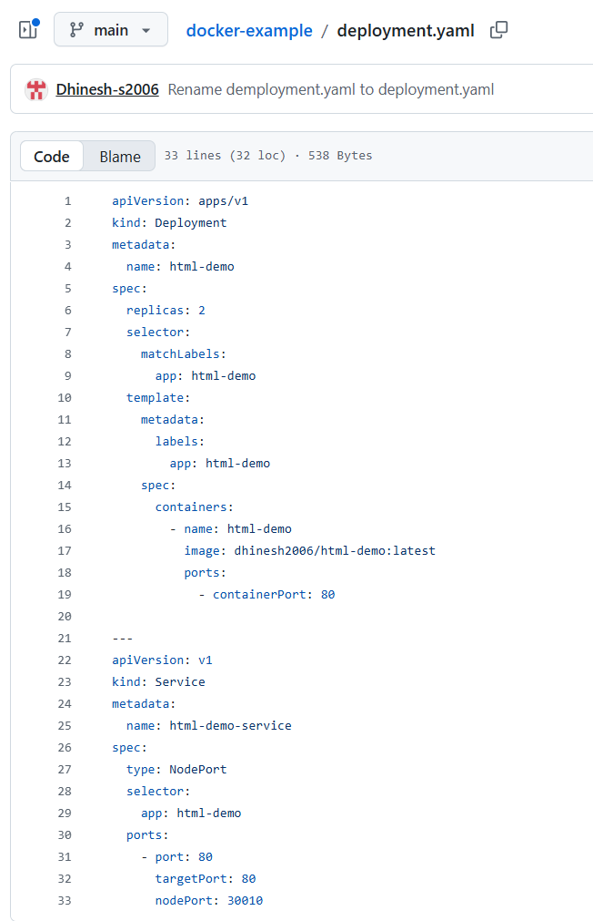
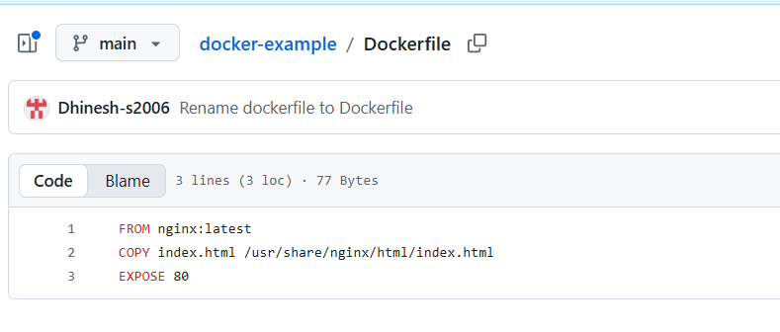
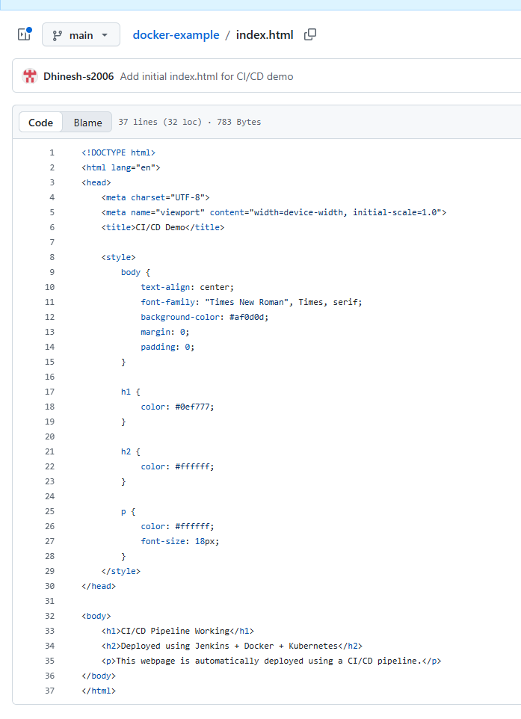

Step 2: Enable Kubernetes
- Open Docker Desktop
- Go to Settings → Kubernetes
- Enable Kubernetes
- Click Apply & Restart
This creates a local Kubernetes cluster.
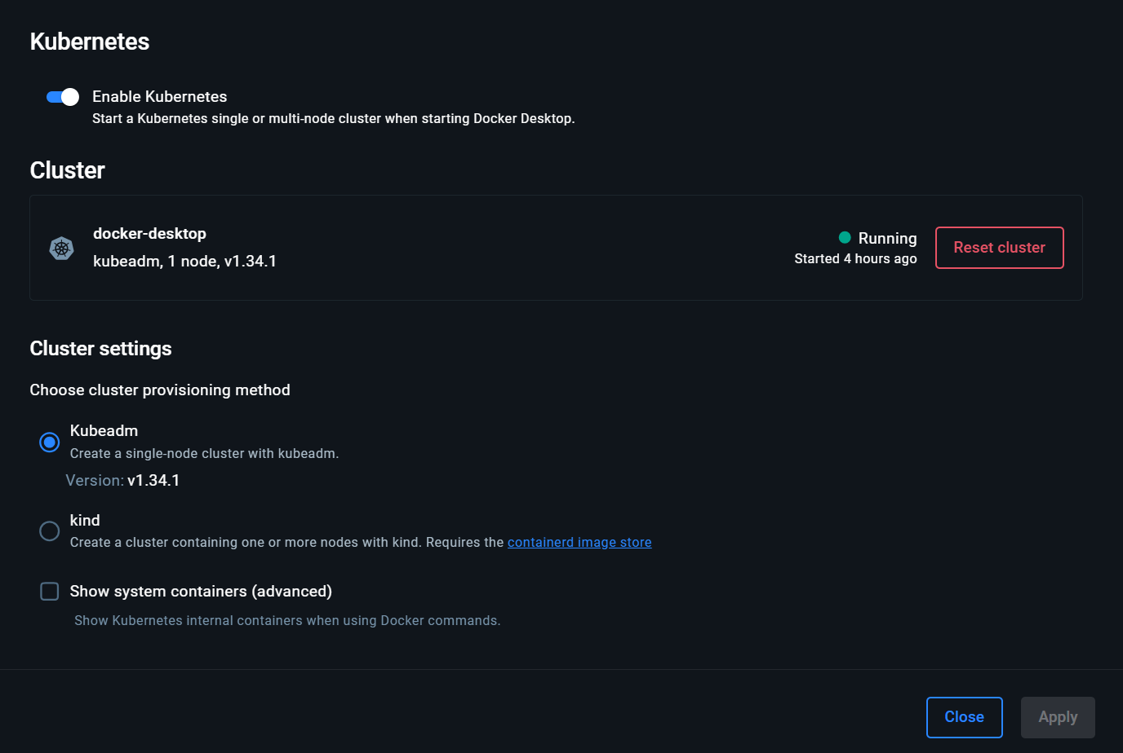
Step 3: Jenkins Setup
Adding Credentials
Two credentials were added in Jenkins:
- DockerHub Credentials
  - Kind: Username with Password
  - ID: dockerhub
- Kubernetes Config
  - Kind: Secret File
  - File: kube config file
  - ID: kuberconfig

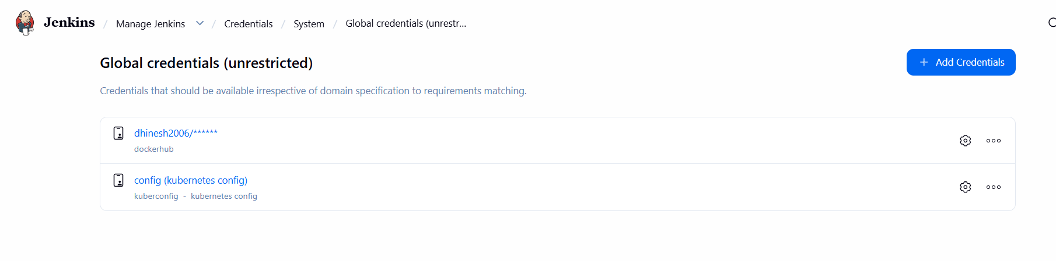

Step 4: Pipeline Creation
A Jenkins pipeline was created with the following stages:
- Clone Code from GitHub
- Build Docker Image
- Push Image to DockerHub
- Deploy to Kubernetes
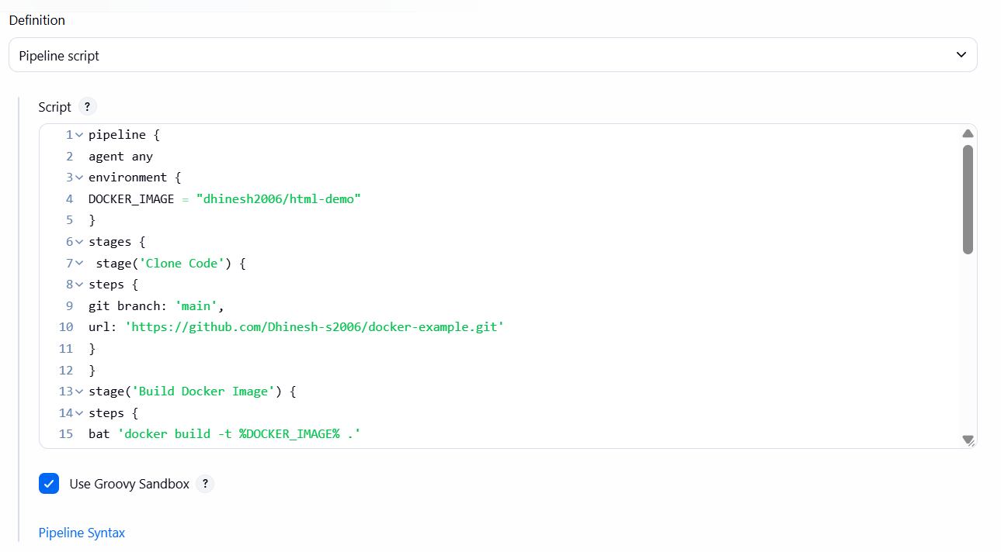
pipeline {
agent any
environment {
DOCKER_IMAGE = "dhinesh2006/html-demo"
}
stages {
stage('Clone Code') {
steps {
git branch: 'main',
url: 'https://github.com/Dhinesh-s2006/docker-example.git'
}
}
stage('Build Docker Image') {
steps {
bat 'docker build -t %DOCKER_IMAGE% .'
}
}
stage('Push Image') {
steps {
withCredentials([usernamePassword(credentialsId: 'dockerhub',
usernameVariable: 'USER', passwordVariable: 'PASS')]) {
bat 'docker login -u %USER% -p %PASS%'
bat 'docker push %DOCKER_IMAGE%'
}
}
}
stage('Deploy to Kubernetes') {
steps {
withCredentials([file(credentialsId: 'kuberconfig', variable:
'KUBECONFIG')]) {
bat '''
set KUBECONFIG=%KUBECONFIG%
kubectl apply -f deployment.yaml --validate=false
'''
}
}
}
}
}

Step 5: Pipeline Execution
The pipeline was executed successfully:
- Code was cloned from GitHub
- Docker image was built
- Image was pushed to DockerHub
- Application was deployed in Kubernetes
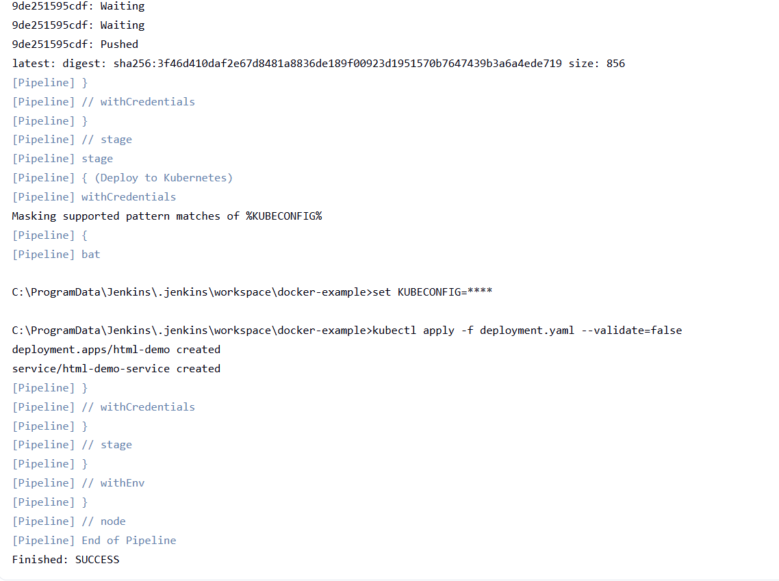

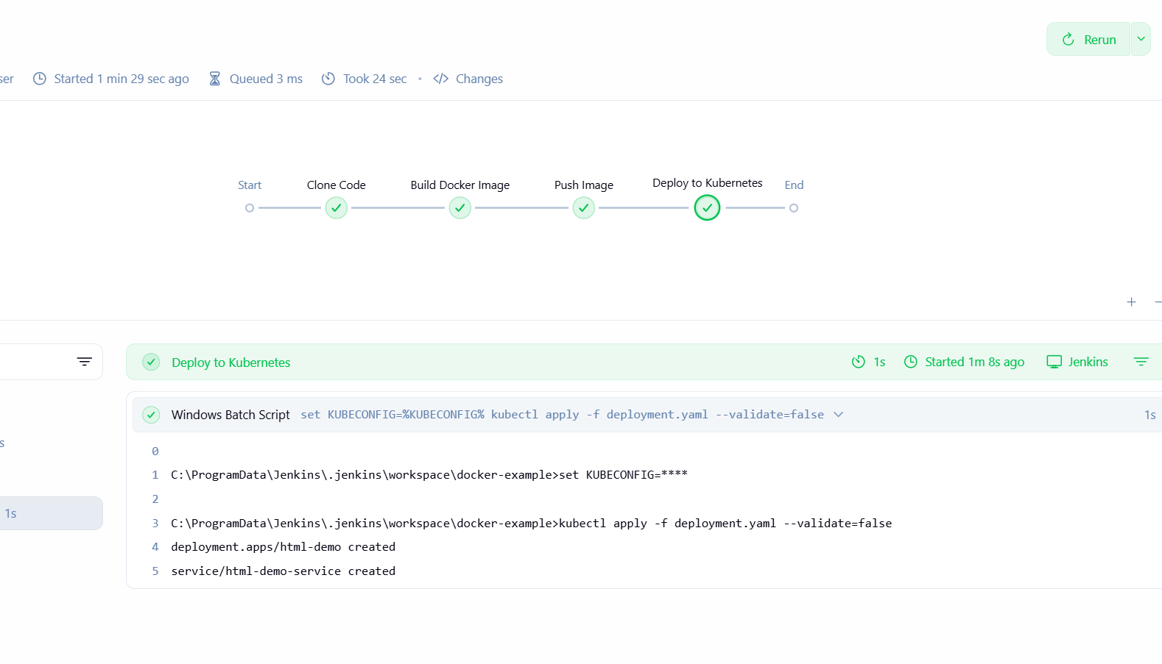
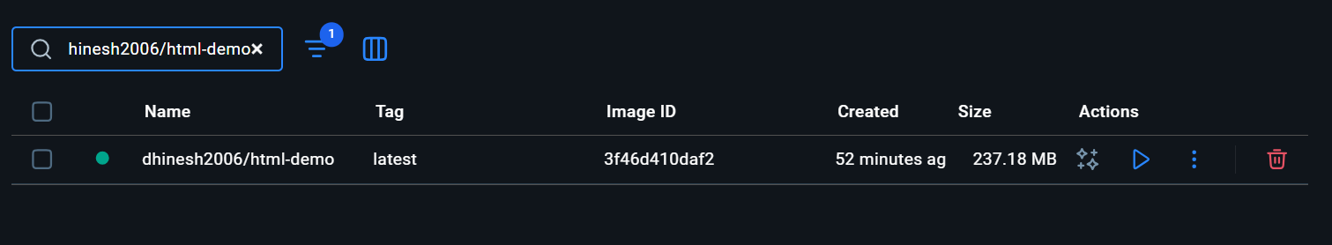

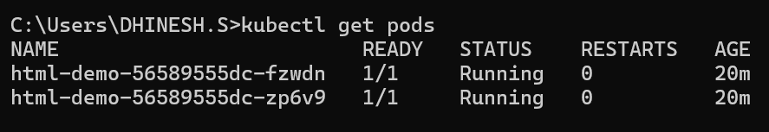

Step 6: Output
The application was successfully deployed and accessed using:
http://localhost:30010
The webpage displayed:
"CI/CD Pipeline Working"

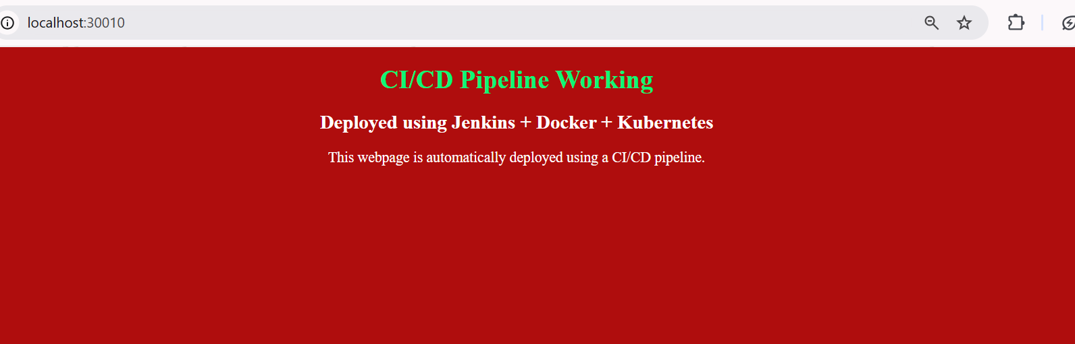

Conclusion
This assignment demonstrates the working of a CI/CD pipeline integrating GitHub, Jenkins, Docker, and Kubernetes. The pipeline automates building, pushing, and deploying applications efficiently.

Result
The CI/CD pipeline was successfully implemented and verified.

